Faculty Information | Name |  | Shin, Kyeonga
Faculty Information | E-mail |  | kashin@hanyang.ac.kr
Faculty Information | Home University |  | Hanyang University
Faculty Information | Department |  | Dance Dept.
Faculty Information | Homepage
Course Information | Class No. |  | 18056 | Course Code | ISS1058 |  | Credits | 3
Course Information | Course Name |  | Korean Traditional Fan Dance
Course Information | Lecture Schedule |  | Tue-Fri / 1:00 PM - 4:00 PM
Course Information | Course Description |  | This course focuses on a traditional form of Korean fan dance. The course consists of an introduction to Korean folk dance, practicing Korean dance techniques and learning how to perform a traditional Korean fan dance. Students not only learn about traditional Korean fan dance but also gain a deeper understanding of Korean arts and culture.  Korean fan dance also called Buchaechum is one of the most popular traditional dances in Korea performed by a group of female dancers wearing hanbok, a Korean traditional dress. The dancers create natural shapes of flowers, butterflies and waves using the peony-colored fans. Students will master a simple piece of Korean fan dance throughout the course.  * The class is also designed for beginners who don't have any dance experience.
  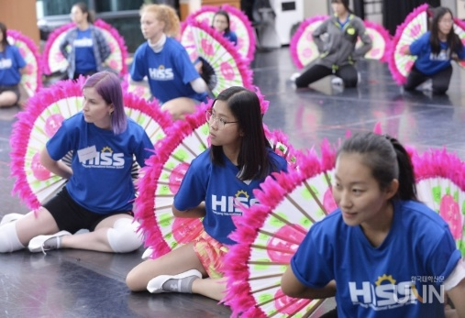 | 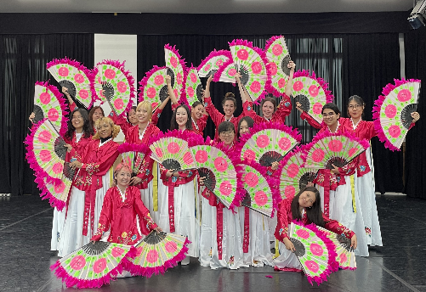
Course Information | Course Objective |  | The goal of the class is to introduce Korean folk dance and traditional culture through hands-on experiences. Students will learn basic Korean dance techniques and work collaboratively with other students to perform the Korean fan dance with music.  * Students will be presenting a fan dance performance at the summer school graduation ceremony. (Not necessarily, depending on students' schedules)
Course Information | Prerequisite |  | The course has no specific prerequisites.
Course Information | Materials/Textbooks |  | - Fans will be provided for class.  - Hanbok(Korean traditional dress) will be provided for a graduation performance.
Evaluation | Attendance |  | 20 % | Quiz |  | %
Evaluation | Assignment |  | % | Mid-term Exam |  | %
Evaluation | Presentation |  | % | Final Exam |  | 60 %
Evaluation | Group Project |  | % | Participation |  | 20 %
Evaluation | Etc. |  | Evaluation Item |  |  | Ratio
Evaluation |  |  |  |  |  | %
Evaluation |  |  |  |  |  | %
Daily  Lecture Plan | Week  1 | Day 1 | Opening Ceremony
Daily  Lecture Plan | Week  1 | Day 2 | Introduction to Korean traditional fan dance
Daily  Lecture Plan | Week  1 | Day 3 | The use of two fans: open & close
Daily  Lecture Plan | Week  1 | Day 4 | The use of two fans with footwork
Daily  Lecture Plan | Week  2 | Day 1 | Fan dance sequence 1
Daily  Lecture Plan | Week  2 | Day 2 | Fan dance sequence 2
Daily  Lecture Plan | Week  2 | Day 3 | Fan dance sequence 3
Daily  Lecture Plan | Week  2 | Day 4 | Fan dance sequence 4
Daily  Lecture Plan | Week  3 | Day 1 | Creation of various formations: natural images using fans by collaboration 1
Daily  Lecture Plan | Week  3 | Day 2 | Creation of various formations: natural images using fans by collaboration 2
Daily  Lecture Plan | Week  3 | Day 3 | Creation of various formations: natural images using fans by collaboration 3
Daily  Lecture Plan | Week  3 | Day 4 | Creation of various formations: natural images using fans by collaboration 4
Daily  Lecture Plan | Week  4 | Day 1 | Practice for performance: Fan dance practice with music 1
Daily  Lecture Plan | Week  4 | Day 2 | Practice for performance: Fan dance practice with music 2
Daily  Lecture Plan | Week  4 | Day 3 | Practice for performance: Fan dance practice with music 3
Daily  Lecture Plan | Week  4 | Day 4 | Final Exam (Fan dance performance by groups)

