Faculty Information | Name |  | Seo, Yeonsoo
Faculty Information | E-mail |  | Ysoo82@hanyang.ac.kr
Faculty Information | Home University |  | Hanyang University
Faculty Information | Department |  | Dance Dept.
Faculty Information | Homepage
Course Information | Class No. |  | 18084 | Course Code | ISS1193 |  | Credits | 3
Course Information | Course Name |  | Traditional Sogo Dance
Course Information | Lecture Schedule |  | Monday-Saturday / 09:00-12:00
Course Information | Course Description |  | ‘Sogo Dance’ refers to a genre of Korean folk dance that originated in the southwestern region of Korea. The term "sogo" roughly translates to "small drum. Sogo Dance is often performed in rural communities during festive occasions, agricultural rituals, and community gatherings in Korea. Sogo Dance typically features dancers wearing colorful traditional Korean attire and dancing to the rhythmic beats of small drums, accompanied by other traditional musical instruments.  The movements of Sogo dance are characterized by lively footwork, dynamic gestures, and rhythmic patterns that reflect the agricultural traditions, rituals, and everyday life of rural communities in Korea. Students will learn how to play Sogo while dancing during class.
  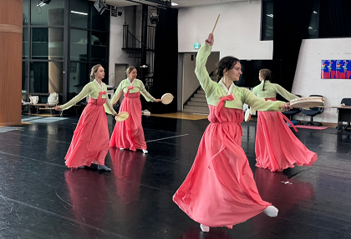 | 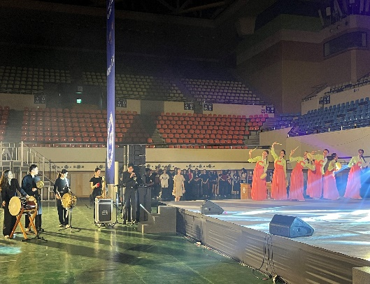
Course Information | Course Objective |  | The goal of the class is for students to learn about the traditional Korean dance, Sogo Dance.  * Students will be presenting a fan dance performance at the summer school graduation ceremony on July 17 (Not necessarily, depending on students' schedules).
Course Information | Prerequisite |  | The course has no specific prerequisites.
Course Information | Materials/Textbooks |  | - Hanbok(Korean traditional dress) will be provided for a graduation performance.
Evaluation | Attendance |  | 20 % | Quiz |  | %
Evaluation | Assignment |  | % | Mid-term Exam |  | %
Evaluation | Presentation |  | % | Final Exam |  | 60 %
Evaluation | Group Project |  | % | Participation |  | 20 %
Evaluation | Etc. |  | Evaluation Item |  |  | Ratio
Evaluation |  |  |  |  |  | %
Evaluation |  |  |  |  |  | %
Daily  Lecture Plan | Week  1 | Day 1 | Introduction to sogo Dance
Daily  Lecture Plan | Week  1 | Day 2 | Korean dance positions and steps 1
Daily  Lecture Plan | Week  1 | Day 3 | Korean dance positions and steps 2
Daily  Lecture Plan | Week  1 | Day 4 | How to play the sogo 1
Daily  Lecture Plan | Week  1 | Day 5 | How to play the sogo 2
Daily  Lecture Plan | Week  2 | Day 1 | Position and role assignment for the sogo dance piece
Daily  Lecture Plan | Week  2 | Day 2 | Sogo Performance Sequence 1
Daily  Lecture Plan | Week  2 | Day 3 | Sogo Performance Sequence 2
Daily  Lecture Plan | Week  2 | Day 4 | Sogo Performance Sequence 3
Daily  Lecture Plan | Week  2 | Day 5 | Sogo Performance Sequence 4
Daily  Lecture Plan | Week  3 | Day 1 | Sequence Practice with sogo 1
Daily  Lecture Plan | Week  3 | Day 2 | Sequence Practice with sogo 2
Daily  Lecture Plan | Week  3 | Day 3 | Dress Rehearsal
Daily  Lecture Plan | Week  3 | Day 4 | Final Exam (Sogo dance performance by groups)

